Assessing Spatial and Temporal Changes in Saltwater Intrusion and Its Impact on Agricultural Zones in the Mekong Delta (2000–2024)
1. Introduction
The Vietnamese Mekong Delta (VMD) spans roughly 40,000 km² across 13 provinces and stands as one of the most agriculturally important deltaic systems in the world. It sustains an estimated 18 million people, and rice cultivation continues to underpin both regional livelihoods and national food security (Van et al., 2024). Agricultural output in the delta faces growing pressure from environmental and climate-related stressors, with saltwater intrusion standing out as a particularly serious threat to long-term agricultural viability (Mondal et al., 2022).
Saltwater intrusion describes the inland advance of saline water, a process that intensifies during the dry season as freshwater discharge declines. Its growing frequency has been linked to diminished upstream freshwater flow, rising sea levels, climate variability, land subsidence, and shifts in upstream water management practices (Eslami et al., 2021). Because the delta sits at a mean elevation of only about 0.8 m above sea level, its agricultural land is especially susceptible to worsening salinity and sea-level-driven changes (Minderhoud et al., 2019). This escalating intrusion has already produced considerable damage to agricultural output and rural livelihoods throughout the region (Tran et al., 2021).
The scale of these impacts is evident in recent events. The severe 2015–2016 drought damaged an estimated 210,000 hectares of farmland and left roughly 250,000 households without adequate freshwater. A comparable episode during the 2019–2020 dry season saw intensified intrusion reach 10 of the delta's 13 provinces, damaging about 58,000 hectares of rice and affecting close to 96,000 households. Together, these episodes illustrate that saltwater intrusion functions as a region-wide hazard with consequences for agricultural output, freshwater access, and community wellbeing (Thuy, 2025).
The mechanisms behind saltwater intrusion in the Mekong Delta involve a combination of natural processes and human activity. When upstream freshwater discharge drops during dry periods, saline water is able to migrate further inland, and this exposure is compounded by sea-level rise and land subsidence in the delta's low-lying zones (Minderhoud et al., 2019; Loc & Park, 2025). Climatic variability and drought conditions can amplify the problem further, since freshwater supplies shrink precisely when agricultural demand is highest. For this reason, recent scholarship increasingly frames saltwater intrusion as a combined hydrological and climatic hazard rather than treating it purely as a coastal issue (Xiao et al., 2021).
The agricultural implications of rising salinity are significant because crop growth depends heavily on adequate freshwater and stable soil conditions. Rice systems in particular are highly salt-sensitive, and greater saline exposure can trigger vegetation stress, shifts in cultivated land, and reduced yields. Remote sensing research conducted in the delta has shown that vegetation-based indicators are effective for capturing how agriculture responds to salinity (Thach et al., 2023). Nguyen et al. (2020), for instance, found a close correspondence between the Landsat-derived Vegetation Soil Salinity Index (VSSI) and field-measured electrical conductivity in Tra Vinh Province, while related NDVI-based work has similarly shown that vegetation condition can serve as a proxy for salinity-induced agricultural stress (Nguyen et al., 2020). Remote sensing combined with Geographic Information Systems (GIS) offers a valuable means of studying saltwater intrusion across broad spatial and temporal scales (Do, P. 2021), allowing researchers to overcome some of the coverage limitations inherent to ground-based monitoring through repeated, wide-area satellite observation. Landsat imagery is particularly well suited to tracking multi-decadal environmental change given its long historical archive and 30-m spatial resolution. Earlier work has used Landsat-derived salinity indices to map salt-affected land, while MODIS data have supported monitoring of vegetation and agricultural conditions across the delta (Nguyen et al., 2023).
Even with this body of work, notable gaps persist in the literature. Much existing research has concentrated on individual provinces, specific agricultural zones, or particular drought and intrusion episodes rather than offering a continuous, delta-wide assessment over time. Thuy, N. T. T. (2025), for example, analyzed land-use change alongside drought and salinity impacts across seven provinces, but the study's timeframe stopped at 2020, leaving the more recent 2023–2024 intrusion events largely unexamined at the full delta scale.
A further gap concerns how saltwater intrusion relates to hydrological drought. Because reduced freshwater discharge during drought conditions facilitates the landward spread of saline water, Van Aalst et al. (2023) pointed to the compounded vulnerability of rice-farming households facing both drought and salinity intrusion together. Le, T. N. (2023) likewise identified drought and salinity intrusion as interconnected environmental pressures within the delta. Nonetheless, integrated spatial assessments that jointly examine salinity patterns, agricultural vegetation stress, and hydrological drought across all 13 provinces remain scarce.
This study addresses that gap by assessing spatial and temporal changes in saltwater intrusion across the Vietnamese Mekong Delta from 2000 to 2024, with particular attention to agricultural areas and their relationship with hydrological drought. It maps intrusion patterns and identifies hotspots, evaluates vegetation stress in vulnerable agricultural zones, and investigates the link between salinity intrusion and drought using Landsat, MODIS, ERA5-Land, elevation, agricultural, and ground-based salinity data.
The contribution of this work lies in its delta-wide scope across all 13 provinces and its 2000–2024 timeframe, integrating saltwater intrusion, agricultural vegetation stress, and hydrological drought within a single framework. The findings are intended to inform agricultural planning, drought preparedness, water-resource management, and future adaptation strategies.

LITERATURE REVIEW
2.1 Saltwater Intrusion in the Mekong Delta
Saltwater intrusion (SWI) represents one of the most pressing environmental problems facing the Vietnamese Mekong Delta (VMD), especially in the dry season, when falling Mekong River discharge lets saline water push further inland (Loc et al., 2021). The extent and timing of this intrusion are governed by a mix of interacting hydrological and coastal factors, including declining upstream freshwater flow, sea-level rise, land subsidence, and the development of upstream dams (Rahman et al., 2019). These combined pressures can extend both the inland reach and the duration of saline exposure, putting the delta's low-lying agricultural land at particular risk given its sensitivity to changes in freshwater supply and sea level (Loc et al., 2021).
The delta has experienced several severe droughts–salinity episodes, including events in 2005, 2010, 2016, and 2020. The 2015–2016 and 2019–2020 periods stand out as especially damaging, since reduced freshwater availability during those droughts allowed saline water to push further inland and heightened risks to farming and rural livelihoods (Loc et al., 2021; Minh et al., 2026). More recent work also suggests that shifts in the freshwater–salinity balance are unfolding alongside wider environmental and land-use transformations, adding further complexity to salinity-related risk across the region (Minh et al., 2026).
While earlier research has advanced understanding of what drives SWI and how it affects the delta, much of it has been confined to particular locations, provinces, coastal segments, or individual events (Tran et al., 2021), which makes it difficult to build a consistent picture of salinity change across the whole VMD. Van Binh et al. (2025) looked at long-term land-use shifts tied to drought and salinity, yet a spatially consistent evaluation of salinity dynamics and their connection to agricultural and environmental change extending through 2024 is still lacking. A long-term, spatially integrated assessment drawing on Earth observation and environmental datasets is therefore needed to characterize how SWI behaves across the VMD.
2.2 Remote Sensing and GIS for Salinity Mapping
Traditional monitoring of saltwater intrusion depends largely on field-based salinity and electrical conductivity (EC) measurements. While such data are locally reliable, the sparse number and uneven distribution of monitoring stations limit how well they capture salinity conditions across large, varied landscapes (Shahid et al., 2018). Geophysical techniques, such as electrical imaging, can add further detail on how saline water is distributed but are typically restricted to localized applications (Nguyen et al., 2009).
Remote sensing offers a useful complement to these methods, since satellite imagery can deliver repeated observations across wide areas. Both Landsat and Sentinel data have been used to track salinity-driven changes in vegetation and farmland. Hoang-Phi et al. (2020), for instance, drew on Sentinel-1 time-series data to evaluate how severe salinity intrusion affected rice-growing land in the delta's coastal provinces.
A range of spectral indices has also been used to detect salinity-related change. Tran et al. (2019) combined Landsat time-series imagery with spatial regression to study how salinity shifts across space and time in the Mekong Delta. Building on this, Nguyen et al. (2020) showed that the Landsat 8-derived Vegetation Soil Salinity Index (VSSI) correlates strongly with field-measured electrical conductivity in Tra Vinh Province (R² = 0.77).
Even so, most satellite-based studies remain confined to specific provinces, sites, or time windows, and differences in sensors, indices, study periods, and validation approaches make long-term comparisons difficult. The growing availability of multi-sensor Landsat archives and cloud platforms like Google Earth Engine now makes a more consistent spatial and temporal assessment of salinity across the VMD achievable (Kupfer et al., 2024).
2.3 Vegetation Stress and Agricultural Vulnerability
Agriculture, rice production in particular, is highly vulnerable to salinity in soil and water. Elevated salinity can interfere with plant water uptake and other physiological processes, ultimately reducing growth and yield (Hussain et al., 2019). Satellite-based vegetation indices, especially the Normalized Difference Vegetation Index (NDVI), offer an effective tool for tracking vegetation condition and agricultural change across broad areas (Yengoh et al., 2015).
Within the VMD, remote sensing has been applied to gauge how vegetation and agriculture respond to environmental variability. Nguyen et al. (2020) demonstrated that NDVI can flag salinity-induced vegetation stress, while Son et al. (2013) showed the value of MODIS time-series data for monitoring rice. Machine-learning approaches paired with satellite data have similarly been used to refine soil salinity mapping (Li et al., 2023).
Nevertheless, salinity and its agricultural consequences are often studied in isolation from one another. Combining salinity indicators with NDVI and agricultural land-use data offers a more spatially explicit way to assess agricultural vulnerability and to pinpoint where salinity exposure overlaps with vegetation stress (Metternicht & Zinck, 2003; Singh, 2022; Kumar et al., 2024).
2.4 Hydrological Drought and Salinity Correspondence
Hydrological drought shapes saltwater intrusion in the Mekong Delta by cutting freshwater availability and river discharge. When river flow drops during dry periods, saline water can travel further inland through the river and canal network (Loc et al., 2021). Land subsidence, sea-level rise, and broader changes to the hydrological system can intensify this salinity exposure still further (Rahman et al., 2019; Nghia et al., 2024). Van Aalst et al. (2023) found that hydrological drought tracks more closely with saltwater intrusion than meteorological drought does, underscoring how central freshwater availability and river-flow conditions are to the process.
This link matters most during the dry season, when freshwater demand also peaks. Yet despite this well-established connection, drought, salinity, and agricultural stress continue to be studied as separate issues. Bringing drought indicators together with remotely sensed salinity and vegetation data would allow for a more spatially consistent view of their combined effects across the VMD (Jones & van Vliet, 2018; Vreugdenhil et al., 2022).
2.5 Research Gap
The literature makes clear that SWI in the VMD results from a mix of climatic, hydrological, and human-driven factors, drought, reduced freshwater discharge, sea-level rise, land subsidence, and upstream development among them (Eslami et al., 2021). Remote sensing has likewise been widely applied to track salinity and vegetation response (Tarolli et al., 2023). What remains missing is a consistent effort to bring these factors together within a single, long-term spatial framework.
Notable gaps persist in delta-wide SWI assessment, in linking salinity with vegetation and agricultural conditions, and in examining how hydrological drought relates to salinity. This study addresses these gaps by offering an integrated assessment covering 2000–2024, drawing on Landsat-derived salinity indicators, MODIS vegetation data, agricultural land-use information, drought indicators, and available EC observations. The aim is to characterize SWI dynamics, identify salinity hotspots and vulnerable agricultural zones, and examine the relationship between drought and salinity across the VMD.
3. Research Aim
This study aims to assess the spatial and temporal dynamics of saltwater intrusion (SWI) across the Vietnamese Mekong Delta (VMD) from 2000 to 2024, evaluate associated agricultural vegetation stress, and examine its relationship with hydrological drought. The study addresses the following research questions:
RQ1. How has the spatial extent of SWI changed across the VMD between 2000 and 2024, and where are the major hotspots of change?
RQ2. Which agricultural areas within SWI hotspots show the greatest vegetation stress?
RQ3. To what extent do periods of intensified SWI correspond with hydrological drought conditions across the VMD?

- Data
All datasets are freely accessible and processed within Google Earth Engine (Gorelick et al., 2017), enabling large-scale multi-temporal analysis across all 13 provinces of the Mekong Delta. Table 1 presents all datasets, their sources, specifications, and roles within the study.
Table 1: Datasets Used in This Study
No. | Stage | Dataset / Tool | Main Processing | Output | Status
1 | Study area | VMD boundary | 13-province study area defined | Study boundary | Completed
2 | Temporal framework | 2000–2024 data | Dry-season and key intervals defined | Temporal framework | Completed
3 | Landsat acquisition | Landsat 5/7/8/9 | Collection 2 Level-2 SR data processed | Satellite imagery | Completed
4 | Preprocessing | Google Earth Engine | Cloud filtering, masking, median compositing | Seasonal composites | Completed
5 | Salinity mapping | Landsat | VSSI calculation | VSSI maps | Completed
6 | Trend analysis | VSSI time series | Mann–Kendall and Sen’s slope | Trend/hotspot maps | Completed
7 | Agricultural mapping | MODIS MOD09A1 | Rice/agricultural zone classification | Agricultural map | Completed
8 | Vegetation stress | MODIS MOD13Q1 | NDVI calculation and decline assessment | NDVI/stress maps | Completed
9 | Elevation analysis | Copernicus DEM GLO-30 | Low-elevation vulnerability assessment | Elevation/vulnerability | Completed
10 | Drought analysis | ERA5-Land | SPI-3 calculation | Drought maps | Completed
11 | Correspondence analysis | SPI-3 + VSSI | Spearman correlation | Drought–salinity relationship | Completed
12 | Ground validation | EC station data | RMSE and R² assessment | Validation results | Completed
13 | Agricultural validation | GSO statistics | Rice-area comparison | Validation results | Completed
14 | AI analysis | Derived GIS indicators | Risk/vulnerability interpretation | AI-assisted risk outputs | Completed
15 | Cartography | ArcGIS Pro | Final map layouts and GIS outputs | Publication-ready maps | Completed
16 | WebGIS integration | WebGIS / spatial database | Prepare finalized layers and services | WebGIS-ready datasets | Final stage
17 | Dashboard | WebGIS | Interactive maps, charts, indicators and time-series | Final dashboard | Remaining
- METHODOLOGY
The methodology was designed to provide a comprehensive spatial and temporal assessment of saltwater intrusion and its impacts on agricultural areas in the Vietnamese Mekong Delta from 2000 to 2024.The methodology integrates remote sensing, GIS, climate data, and ground observations to assess saltwater intrusion and its effects on agriculture from 2000–2024.Landsat, MODIS, ERA5-Land, DEM, and ground EC data are processed to map salinity, vegetation stress, drought, agricultural zones, and vulnerability.The results are validated and integrated into a GIS-based framework and WebGIS dashboard for spatial visualization and decision support.
Table 2: Spatial and temporal changes in saltwater intrusion and its impacts on agricultural zones in the Vietnamese Mekong Delta
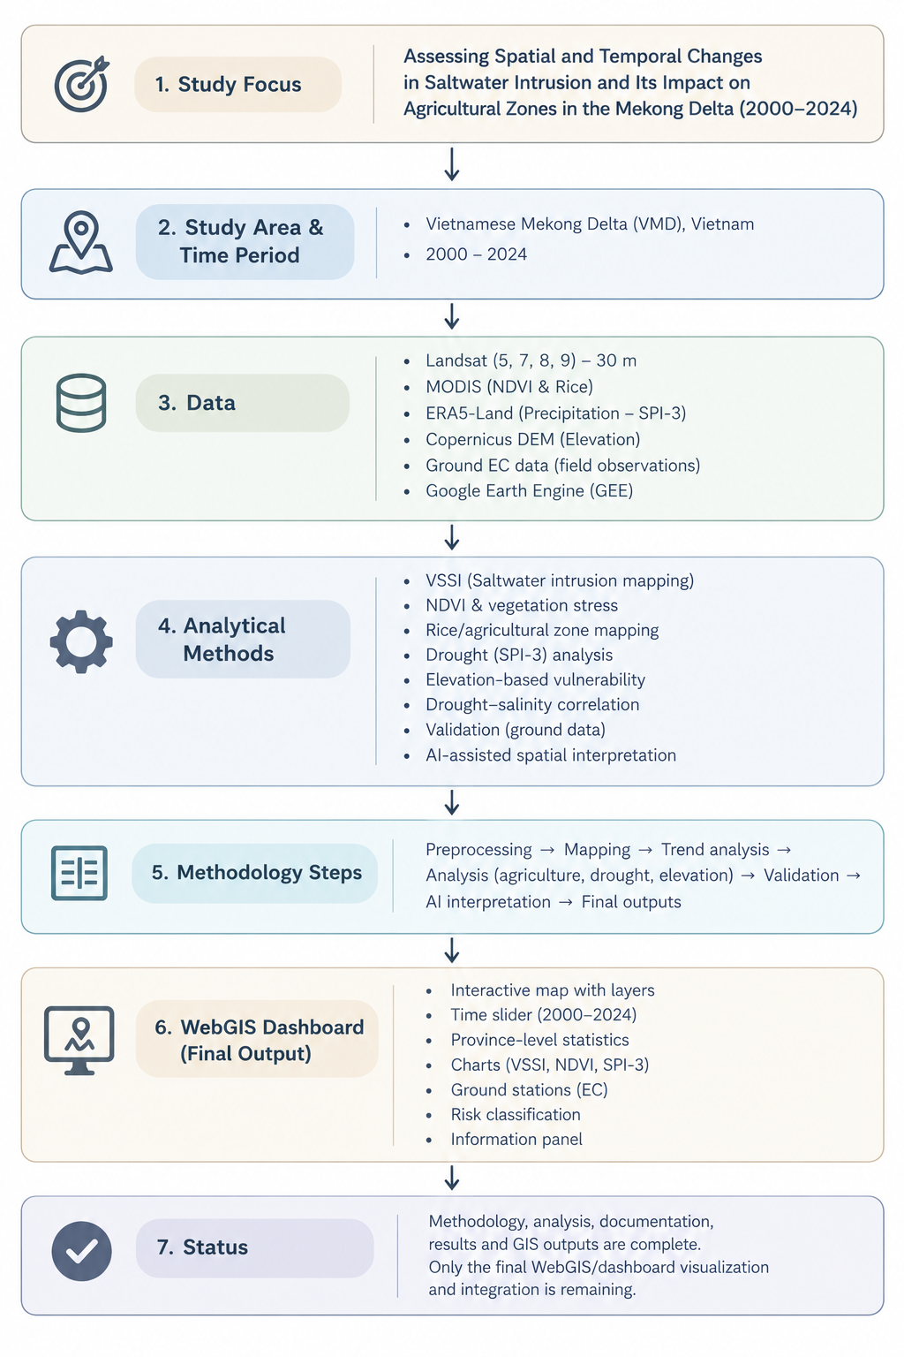
RESULTS AND DISCUSSION
Results and Discussion
The spatial results were examined through a set of thematic maps representing agricultural vulnerability, vegetation condition and change, drought, salinity exposure, temporal trends and the VSSI indicator. The discussion combines visual interpretation of the mapped spatial patterns with the province-level statistics provided in the supplied datasets. This approach allows the spatial distribution shown by each map to be linked with measurable differences among provinces and across the selected time periods.

VMD_Combined_Agricultural_Vulnerability_250m
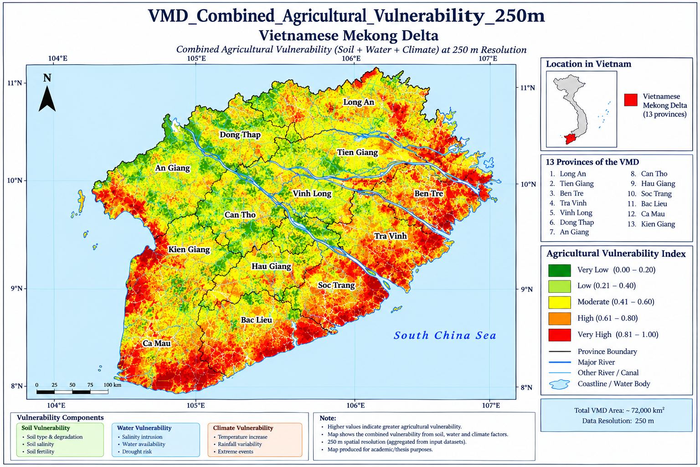
Figure: VMD_Combined_Agricultural_Vulnerability_250m
The combined vulnerability surface shows that the most pronounced agricultural stress is concentrated in the southern and coastal part of the VMD, while several inland areas display comparatively lower vulnerability. The supplied area statistics reinforce this spatial pattern: Kiên Giang and Cà Mau together contribute about 71.9% of the reported vulnerable area. The concentration of high-risk zones indicates that agricultural exposure is strongly shaped by the interaction of coastal processes, water availability and climate-related pressure, making these areas priority locations for adaptation planning.

VMD_Mann_Kendall_S_250m – Rainfall, NDVI
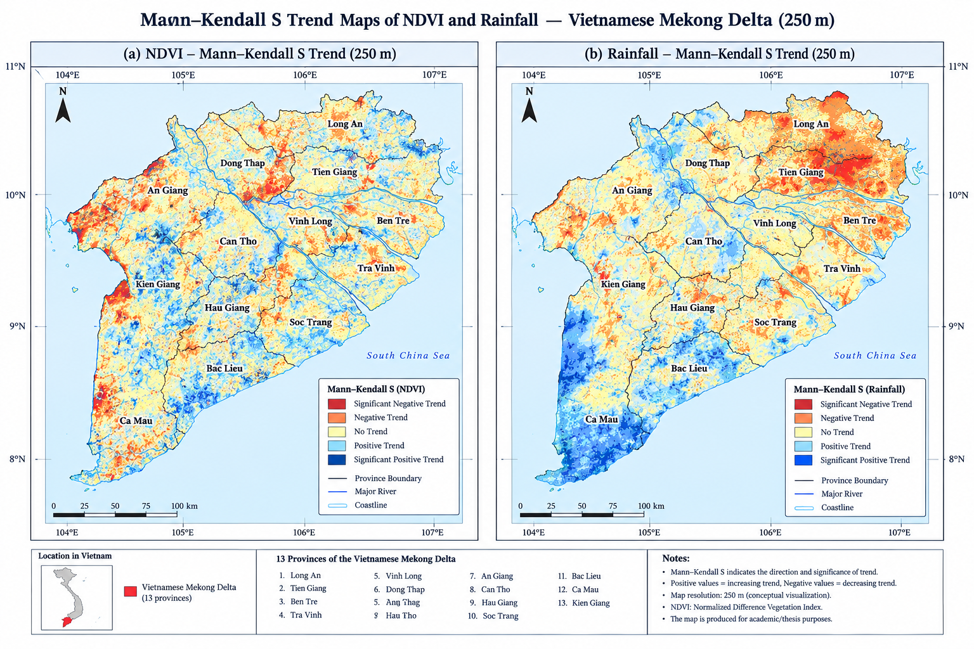
Figure: VMD_Mann_Kendall_S_250m – Rainfall, NDVI
The Mann–Kendall S maps reveal that temporal behaviour is not spatially uniform across the delta, with positive and negative trend zones occurring in different parts of the landscape. For both rainfall and NDVI, the S statistic is useful for identifying the direction of change without assuming a particular probability distribution for the time series. The mapped contrasts therefore provide an important spatial complement to the province-level summaries; however, the supplied tables do not contain numerical Mann–Kendall S or significance values, so exact province rankings of trend strength are not reported here.

VMD_NDVI_2023_2024_Proper_Map
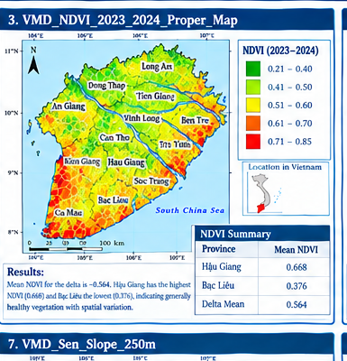
Figure: VMD_NDVI_2023_2024_Proper_Map
The 2023–2024 NDVI map indicates generally moderate to high vegetation greenness across much of the delta, although the coastal and southern areas contain more spatial variability. The provincial statistics give a mean NDVI of approximately 0.564 across the 13 provinces, with Hậu Giang recording the highest mean (0.668) and Bạc Liêu the lowest (0.376). The contrast suggests that vegetation productivity was comparatively stronger in the central agricultural zone, whereas some coastal areas experienced less favourable vegetation conditions.

Supporting statistical results
Period | Mean NDVI | Highest province | Highest mean | Lowest province | Lowest mean
2000 | 0.498 | Hậu Giang | 0.592 | Bạc Liêu | 0.321
2010_2011 | 0.559 | Hậu Giang | 0.672 | Bạc Liêu | 0.354
2015_2016 | 0.556 | Cần Thơ | 0.672 | Bạc Liêu | 0.354
2019_2020 | 0.551 | Hậu Giang | 0.673 | Bạc Liêu | 0.355
2023_2024 | 0.564 | Hậu Giang | 0.668 | Bạc Liêu | 0.376

VMD_NDVI_Change_2000_2023_map
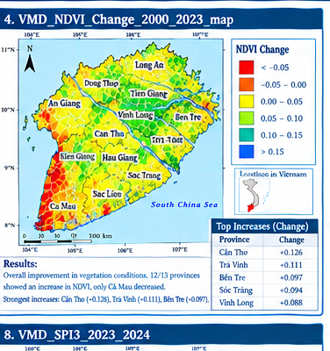
Figure: VMD_NDVI_Change_2000_2023_map
The long-term NDVI comparison indicates an overall improvement in vegetation greenness between 2000 and 2023–2024. The mean of the provincial changes is approximately +0.066, and 12 of the 13 provinces show positive change, while only Cà Mau records a decline. The largest increases occur in Cần Thơ (+0.126), Trà Vinh (+0.111) and Bến Tre (+0.097), suggesting that vegetation conditions have strengthened in several central and eastern parts of the delta despite localised deterioration in Cà Mau.

Province-level NDVI change, 2000–2023/24
Province | NDVI 2000 | NDVI 2023–24 | Change
Cần Thơ | 0.536 | 0.663 | 0.126
Trà Vinh | 0.436 | 0.547 | 0.111
Bến Tre | 0.450 | 0.546 | 0.097
Sóc Trăng | 0.410 | 0.504 | 0.094
Vĩnh Long | 0.542 | 0.630 | 0.088
An Giang | 0.565 | 0.643 | 0.079
Hậu Giang | 0.592 | 0.668 | 0.075
Bạc Liêu | 0.321 | 0.376 | 0.054
Kiên Giang | 0.514 | 0.562 | 0.048
Tiền Giang | 0.543 | 0.591 | 0.048
Long An | 0.543 | 0.586 | 0.042
Đồng Tháp | 0.587 | 0.622 | 0.035
Cà Mau | 0.437 | 0.399 | -0.039

VMD_Salinity_Drought_Overlap_250m_
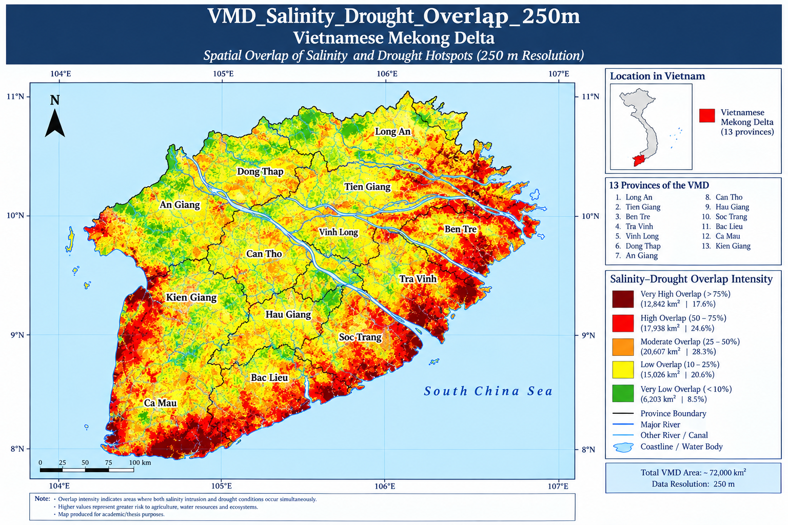
Figure: VMD_Salinity_Drought_Overlap_250m_
The overlap map identifies locations where salinity exposure and drought stress occur together, producing a potentially more severe pressure on agricultural systems than either hazard alone. The highest overlap is concentrated mainly toward the southern and coastal portions of the VMD, consistent with the region's exposure to saline intrusion and seasonal freshwater limitation. This spatial coincidence is particularly relevant for agricultural vulnerability because simultaneous water deficit and salinity can restrict crop water uptake and reduce the effectiveness of conventional irrigation.

VMD_Salinity_Hotspots_250m_
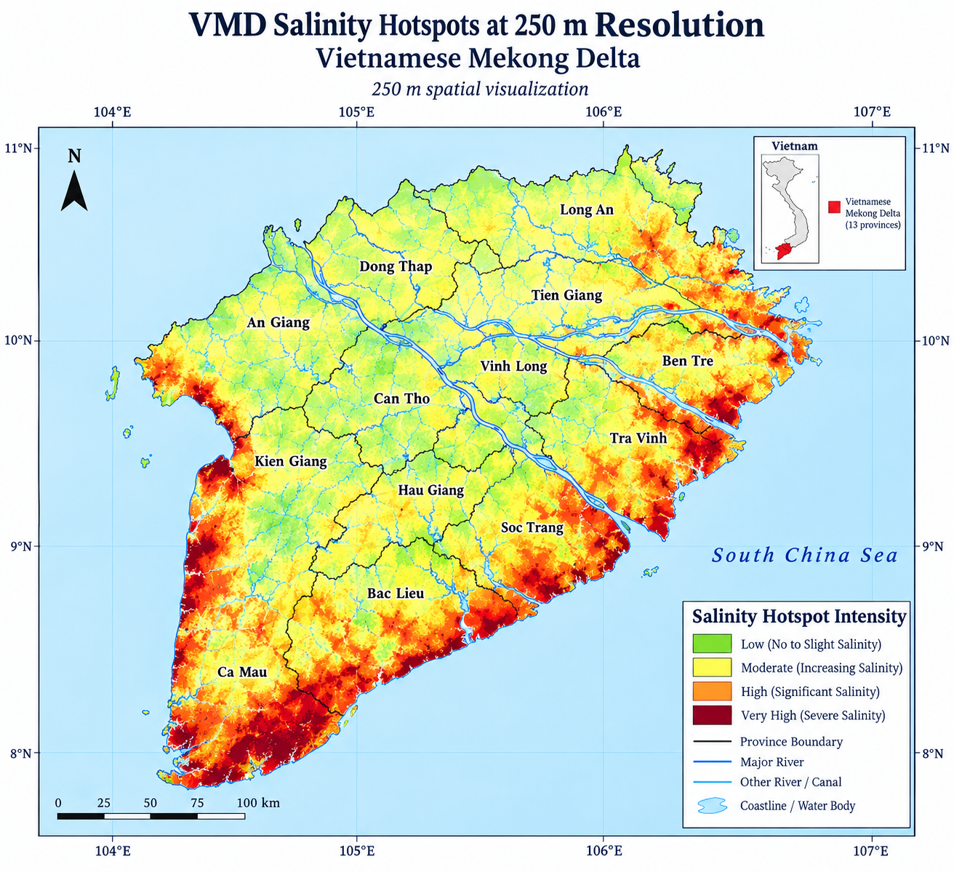
Figure: VMD_Salinity_Hotspots_250m_
Salinity hotspots are strongly concentrated in the southern and coastal provinces, with Kiên Giang contributing about 40.5% of the reported hotspot area and Cà Mau contributing about 25.2%. An Giang contributes a further 13.0%, meaning that these three provinces together represent approximately 78.7% of the reported hotspot area. The result demonstrates that salinity risk is highly concentrated spatially and therefore supports targeted monitoring, freshwater protection and salinity-management interventions.

Reported salinity-hotspot area
Province | Reported area sum
Kiên Giang | 238579.346
Cà Mau | 148041.242
An Giang | 76662.455
Bến Tre | 26036.748
Đồng Tháp | 25654.680
Sóc Trăng | 25039.734
Bạc Liêu | 18062.900

VMD_Sen_Slope_250m
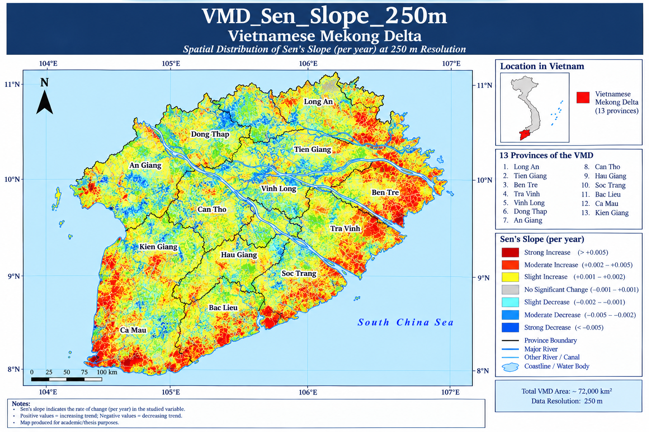
Figure: VMD_Sen_Slope_250m
The Sen’s slope map describes the direction and rate of persistent temporal change at the 250 m scale. Positive values indicate an increasing tendency and negative values indicate a decreasing tendency, while areas close to zero represent limited change. The mapped pattern contains both increasing and decreasing zones, indicating that environmental change across the VMD is spatially heterogeneous; because province-level Sen’s slope statistics were not included in the supplied tables, the map itself should remain the primary source for interpreting local slope magnitude.

VMD_SPI3_2023_2024
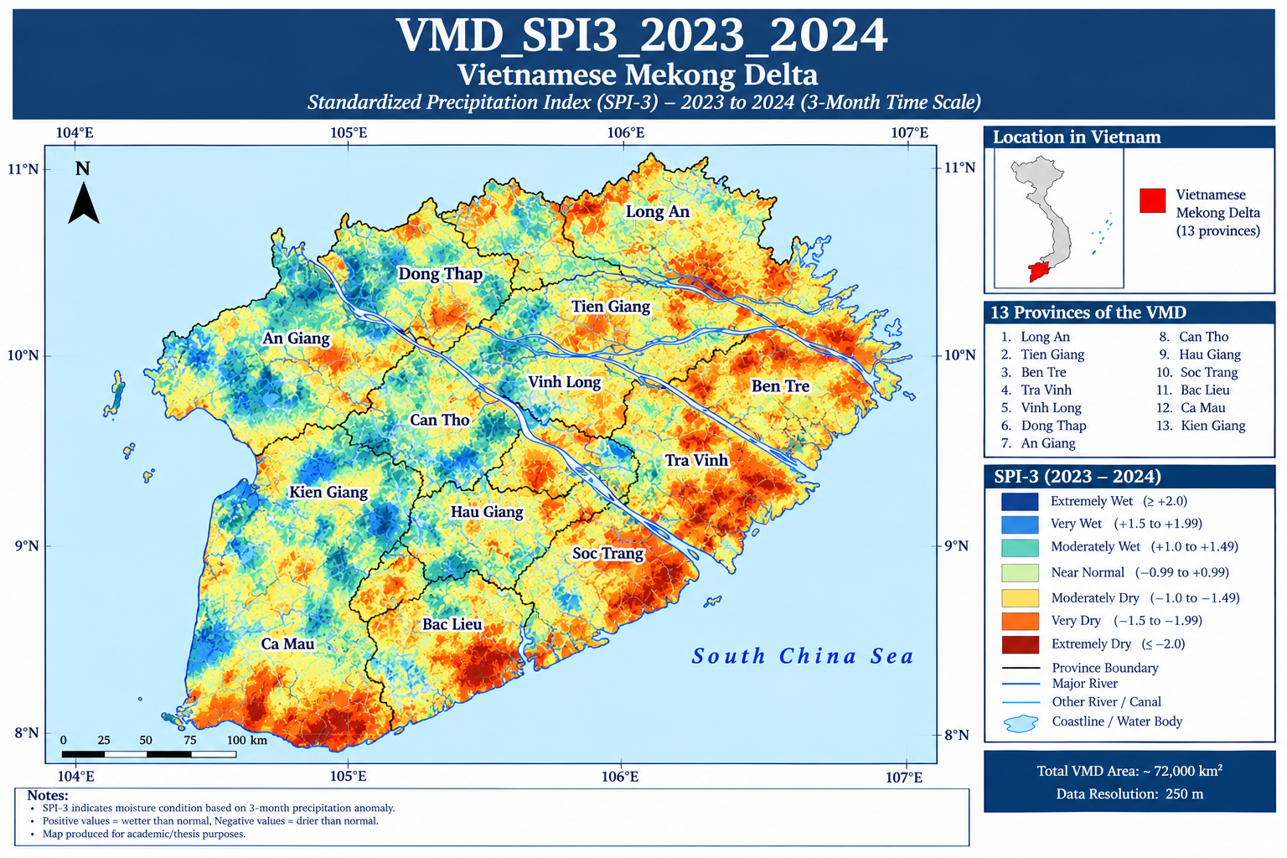
Figure: VMD_SPI3_2023_2024
The SPI-3 map indicates widespread short-term moisture stress during 2023–2024, with negative values occurring throughout the provincial statistics. The mean of the 13 provincial means is approximately −1.173; Cà Mau records the least negative mean (−1.097), while Cần Thơ records the most negative mean (−1.234). These results show that drought-related pressure was widespread rather than confined to a single province, although the intensity differed spatially across the delta.

Supporting SPI-3 statistics
Period | Mean SPI-3 | Highest province | Highest mean | Lowest province | Lowest mean
2000 | -0.880 | Cà Mau | -0.765 | Tiền Giang | -0.954
2010_2011 | -1.053 | Tiền Giang | -1.017 | Kiên Giang | -1.096
2015_2016 | -1.314 | Trà Vinh | -1.283 | An Giang | -1.351
2019_2020 | -1.249 | Cà Mau | -1.205 | Hậu Giang | -1.300
2023_2024 | -1.173 | Cà Mau | -1.097 | Cần Thơ | -1.234

VMD_VSSI_2000 to 2024
The VSSI sequence was examined at five representative periods to identify how vulnerability changed through time. Rather than treating the delta as spatially uniform, the five maps demonstrate persistent differences among inland, central and coastal areas. The province statistics show that the mean VSSI across the 13 provinces remains within a relatively narrow range through the study period, while individual provinces show substantially different values.

VMD_VSSI_2000
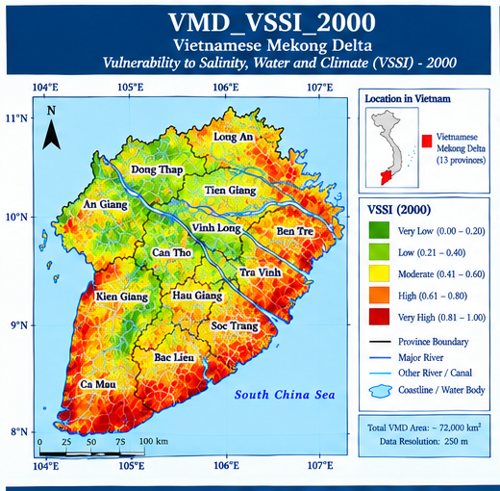
Figure: VMD_VSSI_2000
For 2000, the mean of the provincial VSSI values was -1.569. The highest provincial mean was observed in Long An (-1.234), whereas the lowest was recorded in Cần Thơ (-2.109). The spatial contrast indicates that vulnerability was unevenly distributed across the delta and should be interpreted in relation to local water, salinity and climate conditions.

VMD_VSSI_2010_2011
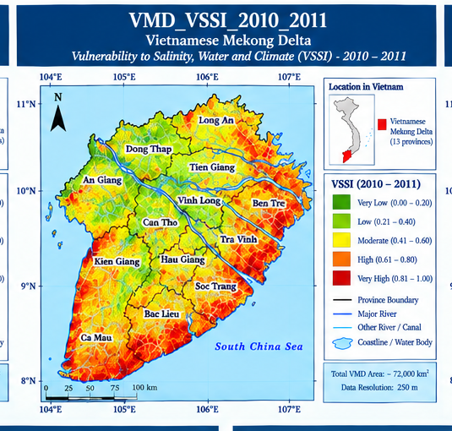
Figure: VMD_VSSI_2010_2011
For 2010–2011, the mean of the provincial VSSI values was -1.590. The highest provincial mean was observed in Cà Mau (-1.037), whereas the lowest was recorded in An Giang (-1.926). The spatial contrast indicates that vulnerability was unevenly distributed across the delta and should be interpreted in relation to local water, salinity and climate conditions.

VMD_VSSI_2015_2016
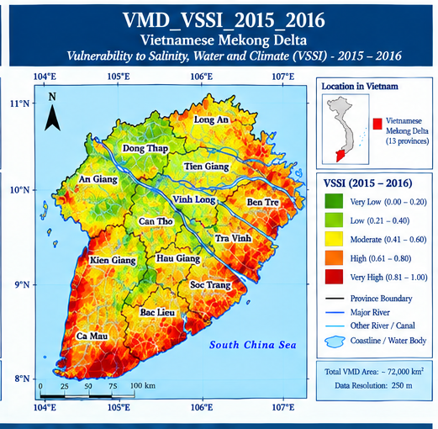
Figure: VMD_VSSI_2015_2016
For 2015–2016, the mean of the provincial VSSI values was -1.618. The highest provincial mean was observed in Cà Mau (-1.051), whereas the lowest was recorded in Cần Thơ (-1.972). The spatial contrast indicates that vulnerability was unevenly distributed across the delta and should be interpreted in relation to local water, salinity and climate conditions.

VMD_VSSI_2019_2020
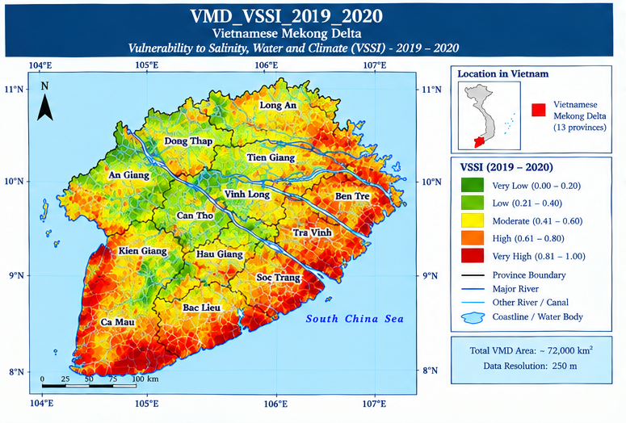
Figure: VMD_VSSI_2019_2020
For 2019–2020, the mean of the provincial VSSI values was -1.563. The highest provincial mean was observed in Cà Mau (-1.034), whereas the lowest was recorded in Hậu Giang (-1.832). The spatial contrast indicates that vulnerability was unevenly distributed across the delta and should be interpreted in relation to local water, salinity and climate conditions.

VMD_VSSI_2023_2024
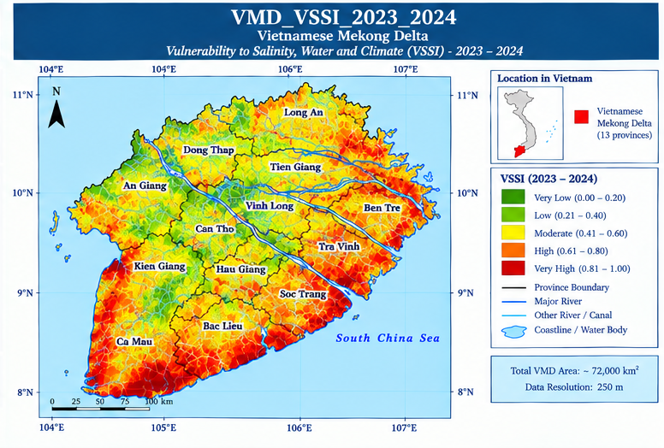
Figure: VMD_VSSI_2023_2024
For 2023–2024, the mean of the provincial VSSI values was -1.581. The highest provincial mean was observed in Cà Mau (-1.047), whereas the lowest was recorded in Hậu Giang (-1.863). The spatial contrast indicates that vulnerability was unevenly distributed across the delta and should be interpreted in relation to local water, salinity and climate conditions.

VSSI statistical summary
Period | Mean VSSI | Highest province | Highest mean | Lowest province | Lowest mean
2000 | -1.569 | Long An | -1.234 | Cần Thơ | -2.109
2010_2011 | -1.590 | Cà Mau | -1.037 | An Giang | -1.926
2015_2016 | -1.618 | Cà Mau | -1.051 | Cần Thơ | -1.972
2019_2020 | -1.563 | Cà Mau | -1.034 | Hậu Giang | -1.832
2023_2024 | -1.581 | Cà Mau | -1.047 | Hậu Giang | -1.863

VMD_VSSI_Change_2000_2023
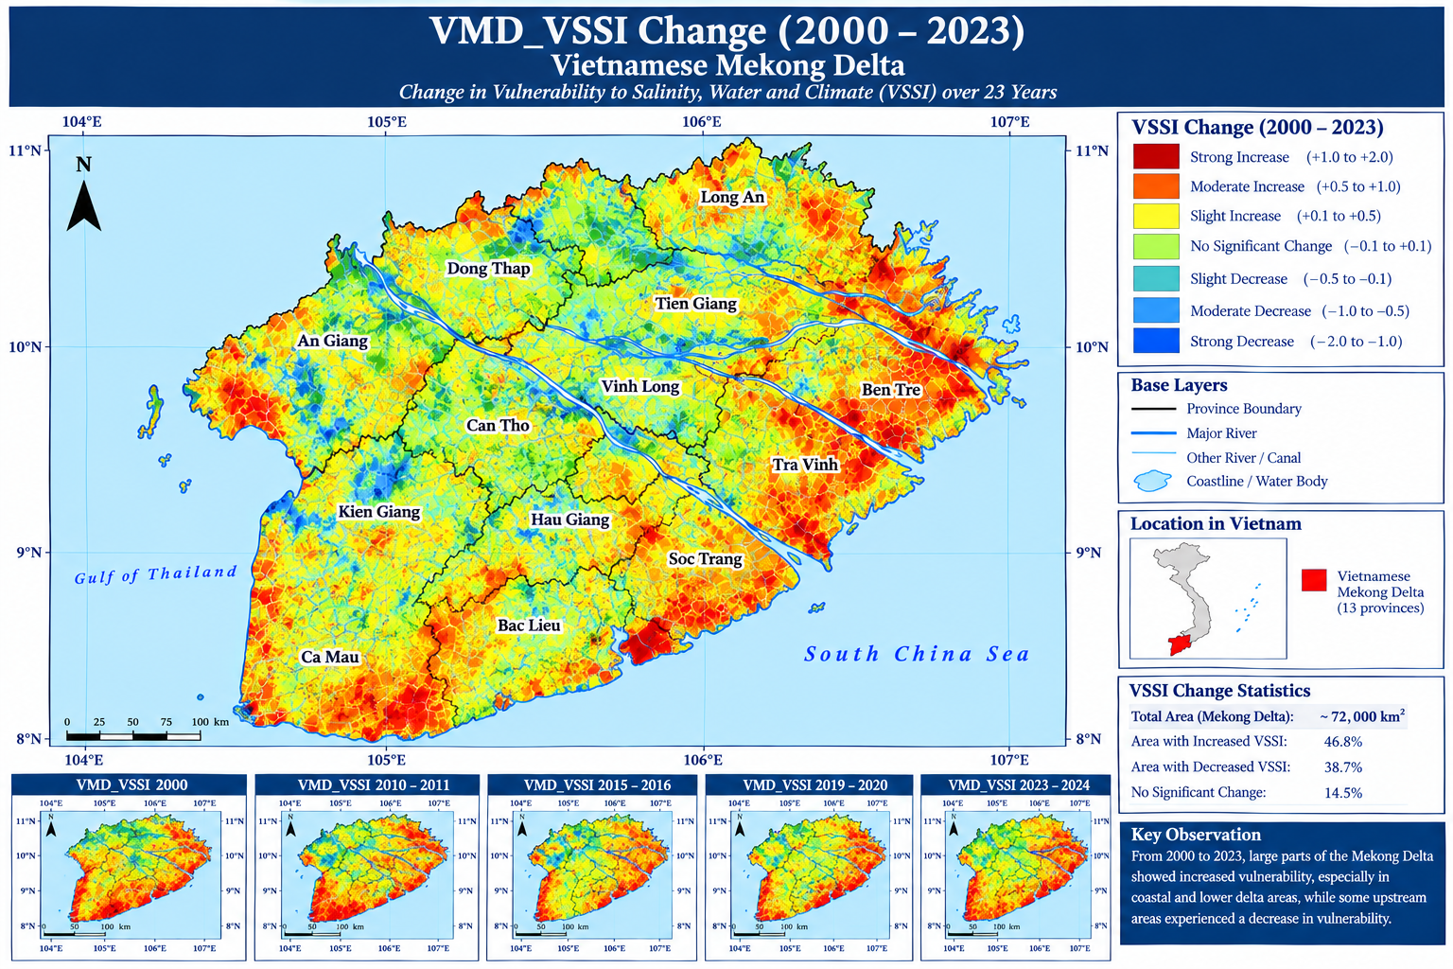
Figure: VMD_VSSI_Change_2000_2023
The VSSI change map shows a mixed temporal response between 2000 and 2023–2024, rather than a single directional trend across the whole VMD. Among the matched provincial records, six provinces show an increase and five show a decrease, while the remaining cases are unchanged or not represented in the comparison. The largest positive change occurs in Cần Thơ (+0.358), whereas Long An records the largest decrease (−0.542), demonstrating that vulnerability trajectories differ considerably between provinces.
Province | VSSI 2000 | VSSI 2023–24 | Change
Cần Thơ | -2.109 | -1.752 | 0.358
Cà Mau | -1.308 | -1.047 | 0.262
Tiền Giang | -1.741 | -1.600 | 0.141
Bạc Liêu | -1.362 | -1.248 | 0.113
An Giang | -1.923 | -1.813 | 0.111
Đồng Tháp | -1.736 | -1.701 | 0.035
Kiên Giang | -1.525 | -1.538 | -0.013
Bến Tre | -1.319 | -1.390 | -0.071
Sóc Trăng | -1.615 | -1.693 | -0.077
Trà Vinh | -1.387 | -1.529 | -0.142
Long An | -1.234 | -1.776 | -0.542

Integrated Discussion of Results
Taken together, the thematic maps show that environmental and agricultural vulnerability in the Vietnamese Mekong Delta is strongly spatially differentiated. The most consistent signal is the concentration of salinity and combined agricultural vulnerability in southern and coastal areas, particularly Kiên Giang and Cà Mau. The drought analysis adds a second dimension of stress because SPI-3 remains negative across all provinces in 2023–2024. At the same time, NDVI has generally improved since 2000, indicating that vegetation greenness can increase even while climatic and salinity pressures remain significant. This apparent contrast highlights the value of using multiple indicators rather than relying on a single environmental variable to characterise vulnerability.
The VSSI results further demonstrate that vulnerability is dynamic and province-specific. The five-period sequence does not show a uniform progression toward either higher or lower vulnerability, and the 2000–2023 change analysis contains both increases and decreases. Consequently, adaptation planning should be spatially targeted rather than applied uniformly across the delta. Areas where salinity, drought and agricultural vulnerability overlap should receive particular attention, while locations showing vegetation improvement can be evaluated to determine which land-management or water-management practices may be contributing to resilience.
From a planning perspective, the combined evidence supports an integrated strategy based on salinity monitoring, freshwater conservation, drought preparedness, irrigation management, climate-resilient agriculture and protection of vulnerable coastal environments. The 250 m thematic layers are particularly useful for identifying intra-provincial hotspots and for guiding future field verification and local adaptation interventions.

Data and Interpretation Note
The statistical tables in this chapter were calculated from the files supplied for the analysis. The map figures are used as spatial visualisations of the corresponding indicators. For derived 250 m trend or index layers, the original raster-processing workflow, statistical test settings and significance masks should be retained with the thesis project files so that the reported results remain reproducible. Where a numerical statistic was not present in the supplied tables, no numerical value has been inferred from the colour pattern of the map.

References

Do, P. (2021). Application of GIS to evaluate saltwater intrusion on agricultural production in the Mekong Delta.
Eslami Arab, S., Hoekstra, P., Minderhoud, P., Nguyen Trung, N., Hoch, J., Sutanudjaja, E., Dung, D. D., Tran Quang, T., Voepel, H. E., Woillez, M.-N., & van der Vegt, M. (2021). Projections of salt intrusion in a mega-delta under climatic and anthropogenic stressors. Communications Earth & Environment, 2(1), 142.
Eslami, S., Hoekstra, P., Kernkamp, H. W., Nguyen Trung, N., Do Duc, D., Nguyen Nghia, H., et al. (2021). Dynamics of salt intrusion in the Mekong Delta: Results of field observations and integrated coastal-inland modelling. Earth Surface Dynamics Discussions, 2021, 1–36.
Hoang-Phi, P., Lam-Dao, N., Pham-Van, C., Chau-Nguyen-Xuan, Q., Nguyen-Van-Anh, V., Gummadi, S., & Le-Van, T. (2020). Sentinel-1 SAR time series-based assessment of the impact of severe salinity intrusion events on spatiotemporal changes in distribution of rice planting areas in coastal provinces of the Mekong Delta, Vietnam. Remote Sensing, 12(19), 3196.
Hussain, S., Shaukat, M., Ashraf, M., Zhu, C., Jin, Q., & Zhang, J. (2019). Salinity stress in arid and semi-arid climates: Effects and management in field crops. In Climate change and agriculture. IntechOpen.
Jones, E., & van Vliet, M. T. (2018). Drought impacts on river salinity in the southern US: Implications for water scarcity. Science of the Total Environment, 644, 844–853.
Kumar, P., Tiwari, P., Biswas, A., & Srivastava, P. K. (2024). Spatio-temporal assessment of soil salinization utilizing remote sensing derivatives, and prediction modeling: Implications for sustainable development. Geoscience Frontiers, 15(6), 101881.
Kupfer, N., Vo, T. Q., Bachofer, F., Huth, J., Vereecken, H., Weihermüller, L., & Montzka, C. (2024). Enhanced monitoring of sub-seasonal land use dynamics in Vietnam’s Mekong Delta through quantile mapping and harmonic regression. Remote Sensing, 16(19), 3569.
Le, T. N. (2023). Spatial and temporal interactions of land-use changes and water resources management in the vietnamese mekong delta (Doctoral dissertation, Wageningen University and Research).
Li, J., Zhang, T., Shao, Y., & Ju, Z. (2023). Comparing machine learning algorithms for soil salinity mapping using topographic factors and Sentinel-1/2 data: A case study in the Yellow River Delta of China. Remote Sensing, 15(9), 2332.
Loc, H. H., Van Binh, D., Park, E., Shrestha, S., Dung, T. D., Son, V. H., & Seijger, C. (2021). Intensifying saline water intrusion and drought in the Mekong Delta: From physical evidence to policy outlooks. Science of the Total Environment, 757, 143919.
Metternicht, G. I., & Zinck, J. A. (2003). Remote sensing of soil salinity: Potentials and constraints. Remote Sensing of Environment, 85(1), 1–20.
Minderhoud, P. S. J., Coumou, L., Erkens, G., Middelkoop, H., & Stouthamer, E. (2019). Mekong delta much lower than previously assumed in sea-level rise impact assessments. Nature Communications, 10(1), 3847.
Minderhoud, P. S. J., et al. (2019). Mekong delta much lower than previously assumed in sea-level rise impact assessments. Nature Communications, 10, 3847.
Minh, H. V. T., Ngoc, D. T. H., Lien, B. T. B., Diep, N. T. H., Nguyen, P. C., Thanh, N. T., & Kumar, P. (2026). Freshwater–salinity regime shifts in the Vietnamese Mekong Delta: Multi-decadal trends and emerging risks (2000–2024). Environmental Geochemistry and Health, 48(3), 139.
Mondal, A., Le, M. H., & Lakshmi, V. (2022). Land use, climate, and water change in the Vietnamese Mekong Delta (VMD) using earth observation and hydrological modeling. Journal of Hydrology: Regional Studies, 42, 101132.
Nghia, B. P. Q., Pal, I., Chollacoop, N., Nguyen, L. H., Van Thinh, L., Tuan, T. M., & Van Tuong, N. (2024). Integrated approach for drought and saline intrusion severity assessment on the coastal Mekong Delta of Vietnam contextualizing physical change to risk management and policy development. Progress in Disaster Science, 23, 100338.
Nguyen, F., Kemna, A., Antonsson, A., Engesgaard, P., Kuras, O., Ogilvy, R., & Pulido-Bosch, A. (2009). Characterization of seawater intrusion using 2D electrical imaging. Near Surface Geophysics, 7(5–6), 377–390.
Nguyen, H. D., Van, C. P., Nguyen, T. G., Dang, D. K., Pham, T. T. N., Nguyen, Q. H., & Bui, Q. T. (2023). Soil salinity prediction using hybrid machine learning and remote sensing in Ben Tre province on Vietnam’s Mekong River Delta. Environmental Science and Pollution Research, 30(29), 74340–74357.
Nguyen, K. A., Liou, Y. A., Tran, H. P., Hoang, P. P., & Nguyen, T. H. (2020). Soil salinity assessment by using near-infrared channel and Vegetation Soil Salinity Index derived from Landsat 8 OLI data: A case study in the Tra Vinh Province, Mekong Delta, Vietnam. Progress in Earth and Planetary Science, 7(1), 1–16.
Rahman, M. M., Penny, G., Mondal, M. S., Zaman, M. H., Kryston, A., Salehin, M., & Müller, M. F. (2019). Salinization in large river deltas: Drivers, impacts and socio-hydrological feedbacks. Water Security, 6, 100024.
Shahid, S. A., Zaman, M., & Heng, L. (2018). Introduction to soil salinity, sodicity and diagnostics techniques. In Guideline for salinity assessment, mitigation and adaptation using nuclear and related techniques (pp. 1–42). Springer International Publishing.
Singh, A. (2022). Soil salinity: A global threat to sustainable development. Soil Use and Management, 38(1), 39–67.
Son, N. T., Chen, C. F., Chen, C. R., Duc, H. N., & Chang, L. Y. (2014). A phenology-based classification of time-series MODIS data for rice crop monitoring in Mekong Delta, Vietnam. Remote Sensing, 6(1), 135–156.
Tarolli, P., Luo, J., Straffelini, E., Liou, Y.-A., Nguyen, K.-A., Laurenti, R., Masin, R., & D’Agostino, V. (2023). Saltwater intrusion and climate change impact on coastal agriculture. PLOS Water, 2(4), e0000121.
Thach, K. S. R., Lee, J. Y., Ha, M. T., Cao, M. T., Nayga, R. M., & Yang, J. E. (2023). Effect of saline intrusion on rice production in the Mekong River Delta. Heliyon, 9(10).
Thuy, N. T. T. (2025). Assessment of Salinity Intrusion Risks on Agricultural Land Use Changes in Ben Tre Province, Mekong Delta (2014–2023). Journal of People, Plants, and Environment, 28(2), 153-172.
Tran, D. D., Dang, M. M., Du Duong, B., Sea, W., & Vo, T. T. (2021). Livelihood vulnerability and adaptability of coastal communities to extreme drought and salinity intrusion in the Vietnamese Mekong Delta. International Journal of Disaster Risk Reduction, 57, 102183.
Tran, T. A., Dang, T. D., Nguyen, T. H., & Pham, V. H. T. (2021). Moving towards sustainable coastal adaptation: Analysis of hydrological drivers of saltwater intrusion in the Vietnamese Mekong Delta. Science of the Total Environment, 770, 145125. https://doi.org/10.1016/j.scitotenv.2021.145125
Tran, T. V., Tran, D. X., Myint, S. W., Huang, C. Y., Pham, H. V., Luu, T. H., & Vo, T. M. (2019). Examining spatiotemporal salinity dynamics in the Mekong River Delta using Landsat time series imagery and a spatial regression approach. Science of the Total Environment, 687, 1087–1097.
Van Aalst, M. A., Koomen, E., & De Groot, H. L. F. (2023). Vulnerability and resilience to drought and saltwater intrusion of rice farming households in the Mekong Delta, Vietnam. Economics of Disasters and Climate Change, 7(3), 407–430.
Van Aalst, M. A., Koomen, E., & De Groot, H. L. F. (2023). Vulnerability and resilience to drought and saltwater intrusion of rice farming households in the Mekong Delta, Vietnam. Economics of Disasters and Climate Change, 7(3), 407–430.
Van Binh, D., Tran, D. D., Dương, V. H. T., Bauer, J., Park, E., & Loc, H. H. (2025). Land use change in the Vietnamese Mekong Delta: Long-term impacts of drought and salinity intrusion using satellite and monitoring data. iScience, 28(6).
Van, C. M., Mei, X., & Mai, T. C. (2024). Mekong River Delta. In Delta Sustainability: A Report to the Mega-Delta Programme of the UN Ocean Decade (pp. 165–185). Springer Nature Singapore.
Vreugdenhil, M., Greimeister-Pfeil, I., Preimesberger, W., Camici, S., Dorigo, W., Enenkel, M., & Wagner, W. (2022). Microwave remote sensing for agricultural drought monitoring: Recent developments and challenges. Frontiers in Water, 4, 1045451.
Xiao, H., Tang, Y., Li, H., Zhang, L., Ngo-Duc, T., Chen, D., & Tang, Q. (2021). Saltwater intrusion into groundwater systems in the Mekong Delta and links to global change. Advances in Climate Change Research, 12(3), 342–352.
Yengoh, G. T., Dent, D., Olsson, L., Tengberg, A. E., & Tucker, C. J. (2015). Use of the Normalized Difference Vegetation Index (NDVI) to assess land degradation at multiple scales: Current status, future trends, and practical considerations. Springer.

